Gizmoball: Weekly Progress Document (Week 3)

CS308 Group MW1

**New issues:**

* Implement core functionality for prototype design individually or as a group and then split up individually for prototype implementation?

Concentrate more on prototypes

* Merge of Greig’s GUI (show screenshots) code and MIT Demo code a good starting point for individual implementation of each prototype?

Yes but no wasting time on building from MIT Demo, rather start from scratch and extract functionality from it

* Do classes KeyConnection and GizmoConnection in model package need an interface to interact with listeners in controller package (does interaction between any controller and model classes need to necessarily happen through interfaces?

No

* Is having one interface IGUI for both BuildGUI and PlayGUI not a good idea (too many methods and responsibilities for class) for interaction with listeners in controller package?

It is but only use interfaces if used/necessary

* Do listener classes need to interact with any other class apart from IGUI class in view package (they do not as it is designed now)?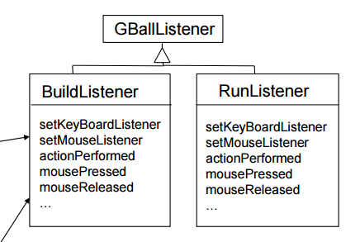

Not necessarily

* Role of GizmoBallL (GBallListener in lecture slides) unclear (see image):

Not needed

* Are key binds supposed to be possible with absorbers, or only with flippers?

Yes, and any other Gizmo (colour change, etc.)

* Better to start prototypes as pairs (two prototypes per pair) or one prototype each and the fifth member assigned to JUnit testing?

Pairs

* Where to start from with JUnit testing?

For every method in a class, test every possible outcome

* Use GitHub instead of GitLab for better integration with IntelliJ IDEA

Cool

**Ongoing issues:**

* N/A

**Resolved issues:**

* All issues from last week.
* Completed and submitted full Preliminary Design
* Joined new git repository on GitLab

**Goals for upcoming week:**

* Decide on git platform and tidy up project on git (Group)
* Read Google Java Style Guide coding standards from lecture slides (<https://google.github.io/styleguide/javaguide.html>) (Group)
* Start integrate physics package to Model (David T. Pocock/Greig Cairns/Tomas Šukevičius)
* Be able to understand and change functionality in both Greig’s GUI and MIT Demo (Group)
* Add separate branches on git for MIT Demo and Greig’s GUI (Group)
* Add board to View (Greig)
* Extract code from MIT Demo (Group)
* Begin constructing the four prototypes, discuss design and implementation:
  + Prototype 2: Collisions (David T. Pocock/Greig Cairns/Tomas Šukevičius)
  + Prototype 4: Flipper (Thomas Mclaughlin/Chris Reilly)

**Git repository history:**

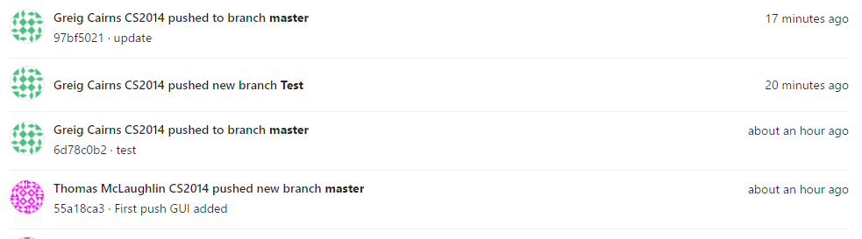

* Group joined new GitLab repository